Calculator Free
The Unit Circle, Radian Measure and Trigonometric Equations

Time: 45 minutes
Total Marks: 45
Your Score: / 45



Question One: [1, 2 = 3 marks]

- Explain what relationship radian measure represents.

- Hence or otherwise explain what 1 radian looks like on a circle with radius 5 cm. Draw a diagram to assist your explanation.

Question Two: [1, 2, 1, 2 = 6 marks]

Express each of these angles as radians, in terms of π, leaving your answers as exact values.

- 180˚ (c) 60˚

- 210˚ (d) 330˚

Question Three: [1, 1, 2, 2 = 6 marks]

Express each of these angles in degrees, leaving answers in terms of π where necessary:

- (c)

- (d)

Question Four: [1, 1 , 1, 1, 2, 2 = 8 marks]

Use the unit circle diagram below to approximate the value of:

Question Five: [1, 1, 1, 1, 1, 3 = 8 marks]

Express each of the following as a simplified exact value:

Question Six: [2, 2, 3, 3, 4 = 14 marks ]

Solve each of the following trigonometric equations over the given domain.

SOLUTIONS
Calculator Free
The Unit Circle, Radian Measure and Trigonometric Equations

Time: 45 minutes
Total Marks: 45
Your Score: / 45



Question One: [1, 2 = 3 marks]

- Explain what relationship radian measure represents.

The ratio between the arc length and the radius.



- Hence or otherwise explain what 1 radian looks like on a circle with radius 5 cm. Draw a diagram to assist your explanation.

The sector drawn has radius 5cm and an arc length of 5 cm if the angle measure is 1 radian.
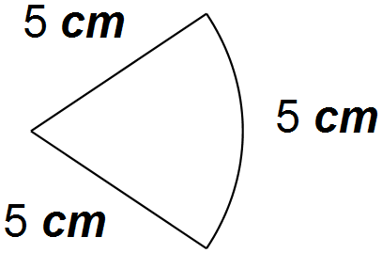



Question Two: [1, 2, 1, 2 = 6 marks]

Express each of these angles as radians, in terms of π, leaving your answers as exact values.

- 180˚ (c) 60˚




- 210˚ (d) 310˚





Question Three: [1, 1, 2, 2 = 6 marks]

Express each of these angles in degrees, leaving answers in terms of π where necessary:

- (c)





- (d)





Question Four: [1, 1 , 1, 1, 2, 2 = 8 marks]

Use the unit circle diagram below to approximate the value of:











Question Five: [1, 1, 1, 1, 1, 3 = 8 marks]

Express each of the following as a simplified exact value:





- 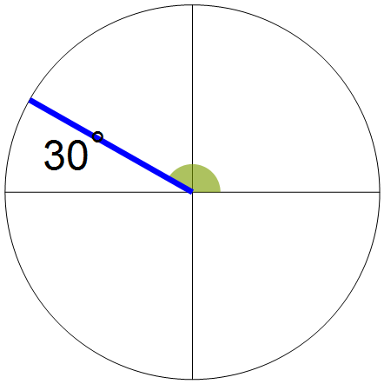



- 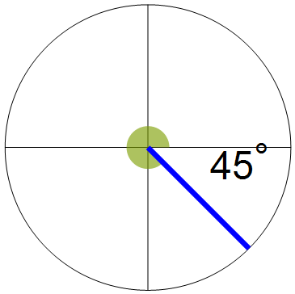


- 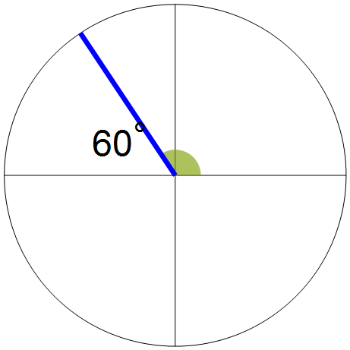





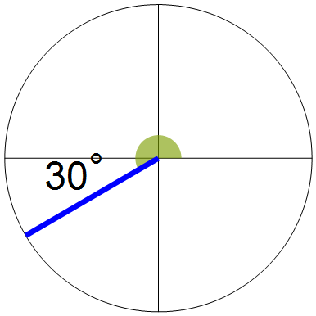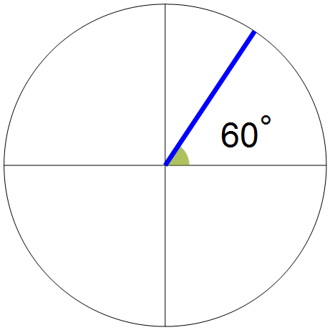

Question Six: [2, 2, 3, 3, 4 = 14 marks ]

Solve each of the following trigonometric equations over the given domain.

- 



 